Hi there! Welcome to my website, all about myself: Gabriel Matthew Whitehair. Though I was born in Indianapolis, IN, I have lived and grown up in Overland Park, KS since I was two. Overland Park is a large suburb of Kansas City, MO on the Kansas side of the state line.

I came to IU because of the Kelley School of Business and because I was already familiar with the state of Indiana. My dad works for Eli Lilly which is headquartered in Indianapolis so that influenced my decision to come here as well.

In high school, I was the varsity golf captain. We won state my sophomore year of high school and placed second the next two years. I was the treasurer of National Honor Society and I was voted “Most Likely to be President” by my pears. I was involved in Boys’ State, Overland Park Teen City Council, Math National Honor Society, Future Business Leaders of America (FBLA), and have over 100 hours of community service. My past work experience includes an internship for Students for Congressman Kevin Yoder, Lifetime Fitness Bistro worker, and a garden tilling business I started with my brothers. Here at Indiana, I am involved in the Indiana University Golf Club, Tee Off at Kelley, and the Real Estate Club. I plan to get more involved on campus in the future.

Below are some of my projects and resume, enjoy my site!

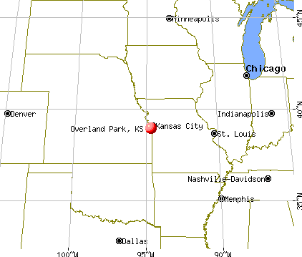

<http://www.city-data.com/city/Overland-Park-Kansas.html>

<https://www.w3docs.com/snippets/html/how-to-embed-pdf-in-html.html>

<https://cdnjs.cloudflare.com/ajax/libs/skeleton/2.0.4/skeleton.min.css>

In my Honors Business Presentations (C106) class in the Kelley School of Business, our biggest project is called the “Macy’s Case.” The Macy’s Case is a competition between C106 groups to see what group can give the best presentation and idea to help the Macy’s corporation. This year’s theme was centered around diversity. Our idea was called the “Home Starts Here” campaign intended to attract those of Latin American descent to feel welcome and accepted in stores. The members of the group were Jayna Dolfi, Brian More, Kurt Taylor, Kyle Zielinski, and Terah Thomas. Attached (click on image or header) is the slide deck. We ended up getting a 98 on the presentation.

In my Topics in Finance (F255) class in the Kelley School of Business, one of our largest projects was the career plan. We had to write a 10-page essay that included pictures and hyperlinks about what our future career aspirations were. In my essay, I outlined some of my possible career paths like investment banking, financial Planning, entrepreneurship, or a computer science route. I also talked about some of my side ideas to make money like flipping houses, mowing lawns, and snow blowing driveways. Finally, I discussed were I wanted to live in the future and some personal aspirations of mine. Attached (click on image or header) is the PDF.

In my Honors Business Presentations (C106) in the Kelley School of Business, our final project was to come up with a business idea that we could pitch to a company to make their company better. I knew right away what I wanted to do: BeerBuddy. I pitched the idea of BeerBuddy to GasBuddy. Just like GasBuddy allows users to compare local prices of gas, BeerBuddy would allow users to compare prices of beer, wine, or liquor anywhere alcohol is sold. In the presentation, I used photoshop to show what the app might look like. I ended up getting a 95 on the project and an A in the class. Attached (click on image or header) is the PowerPoint.

In my Honors Business Presentations (C106) in the Kelley School of Business, one of our major group projects was to give a presentation to two C.H. Robinson representatives on how to improve their recruiting on campus and online. In our presentation we talked about how the company could give out promotional items like frisbees, stress balls, and pens. My area of expertise was how C.H. Robinson could improve their listings on Indeed, Glassdoor, and on their own jobs page by being more concise and adding “Day in the Life of the Job” videos. The members of the group were Jayna Dolfi, Brian More, Kurt Taylor, Kyle Zielinski, and Terah Thomas. We ended up getting a 94 on the presentation. Attached (click on image or header) is the slide deck.